Dynamic inventory file process

Launch ansible master node
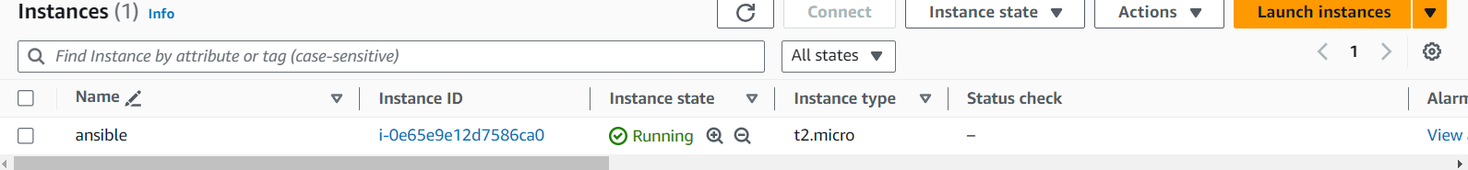

--- attach IAM role to ansible master
- Ec2 – administrator access or Ec2 full access
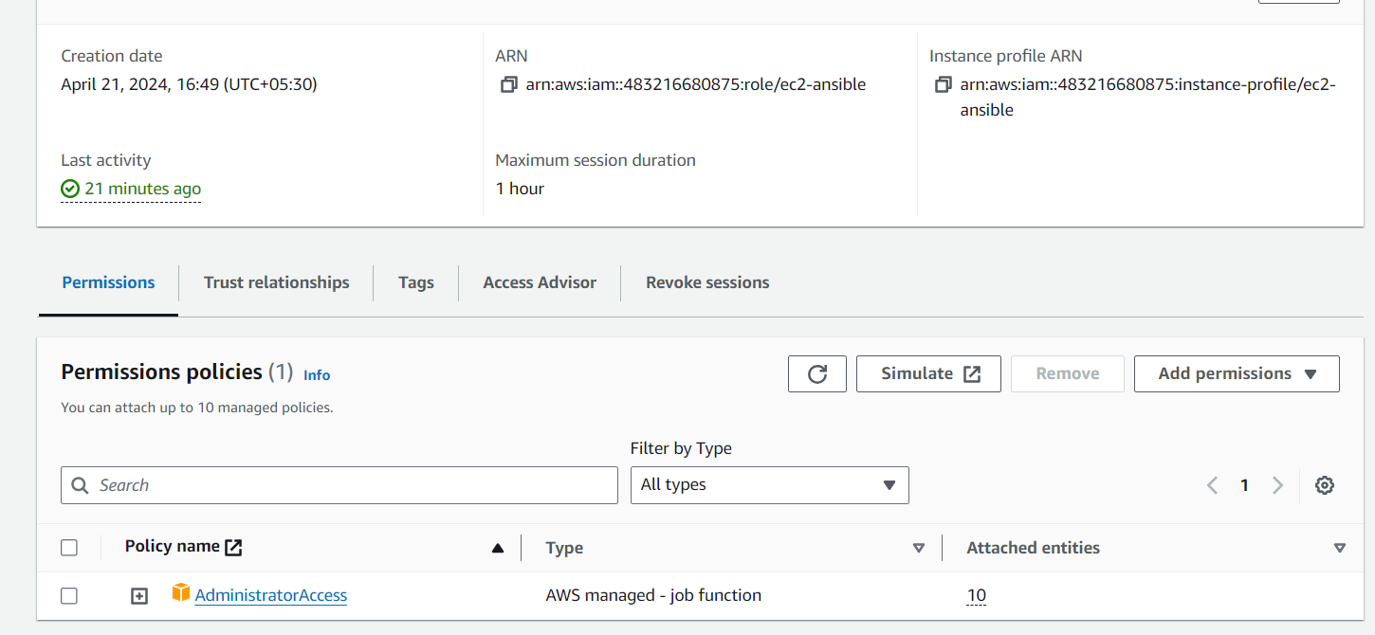
Create a node with name of dev
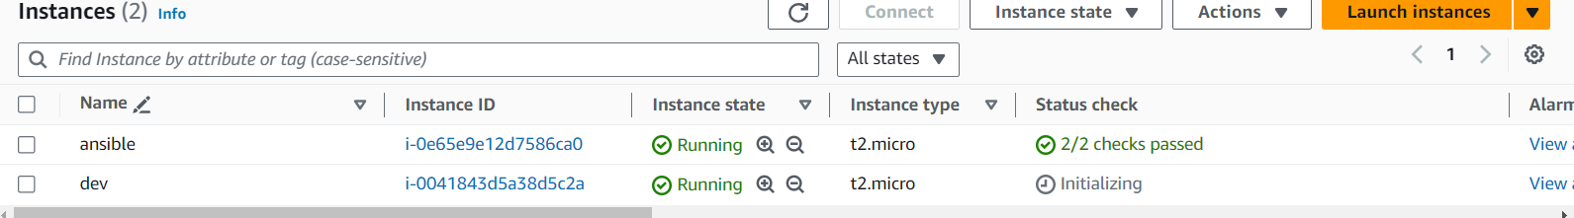

----- Install bellow command in ansible master

sudo yum install ansible -y
sudo yum update -y
sudo yum install python -y
sudo wget https://bootstrap.pypa.io/get-pip.py #download pip (or) yum install python3-pip -y
sudo python get-pip.py
sudo pip install boto3
sudo pip show boto3
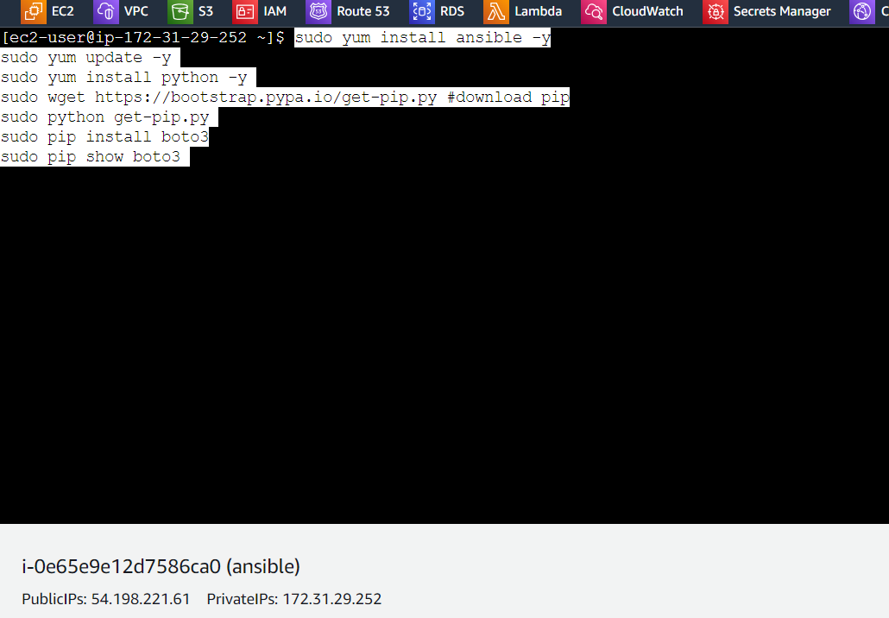
- Install ansible galaxy

- ansible-galaxy collection install amazon.aws
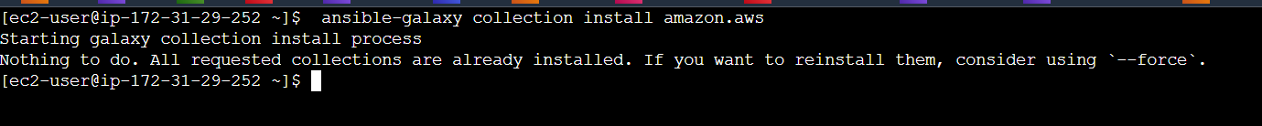
--- generate the keys
- ssh-key gen
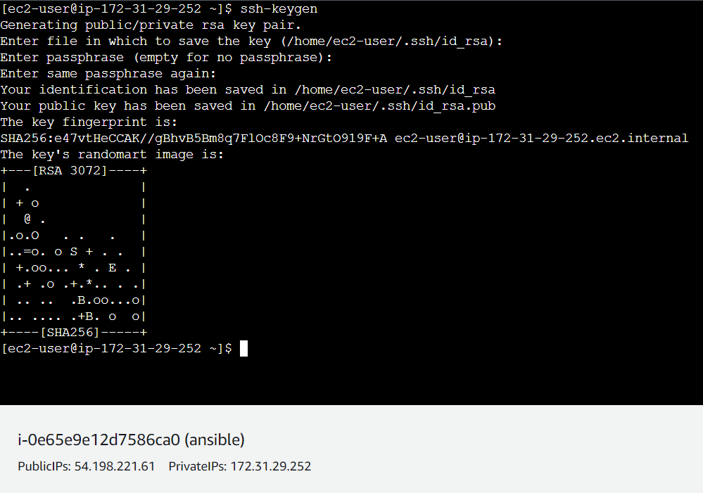
--- copy the public key
- cd .ssh
- cat id_rsa.pub
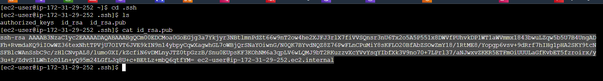

--- paste the public on dev node
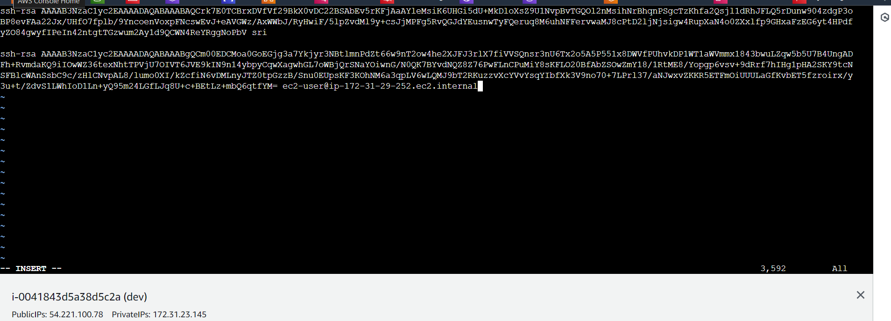

-----go to ansible.cfg file and paste below data
-------sudo vi /etc/ansible/ansible.cfg
[defaults]
enable_plugins = aws_ec2
inventory =./aws_ec2.yml
host_key_checking = False
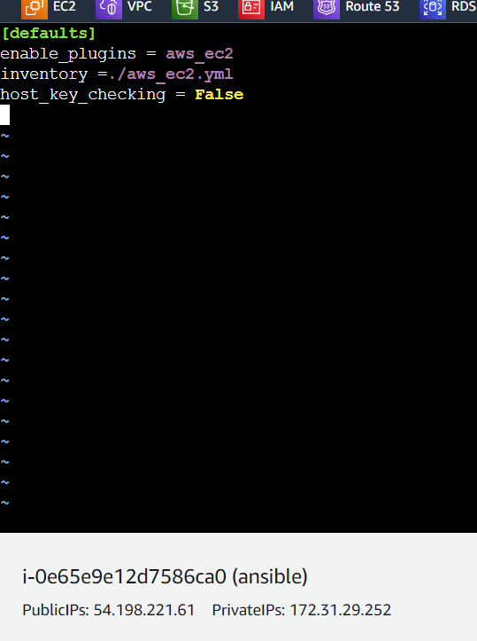

THIS IS FOR HOST =ALL
----create a aws_ec2.ymal file for enable the plugins
- sudo vi /etc/ansible/aws_ec2.yml
- paste the below mater
plugin: amazon.aws.aws_ec2
regions:
- us-east-1
filters:
tag:Name:
- dev
#add multiple tag names here if required
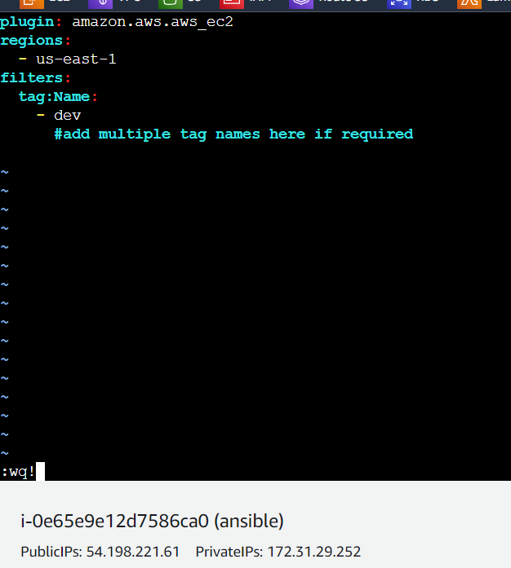

------give the ping command
- ansible all -m ping
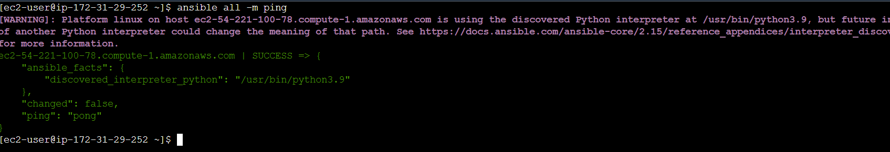

- go to ansible directory apply below list and graph commands to get details
----- cd /etc/ansible/
- ansible-inventory -i aws_ec2.yml --graph
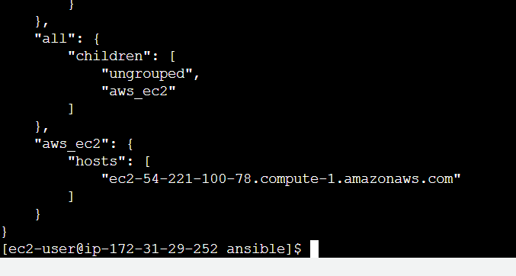

ansible-inventory -i aws_ec2.yml --graph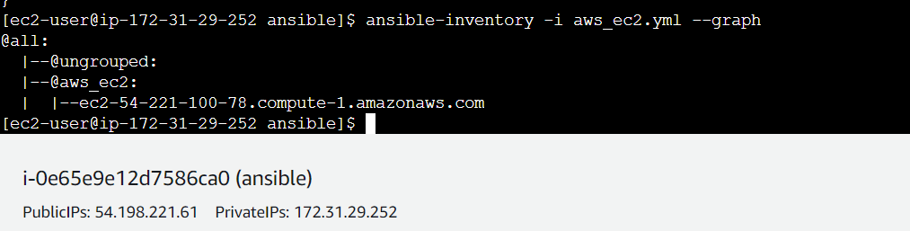

- create a sample playbook in same ansible directory
---
- name: first playbook
hosts: all
become: yes
tasks:
- name: install httpd software
yum:
name: httpd
state: latest
- name: start web server
service:
name: httpd
state: started
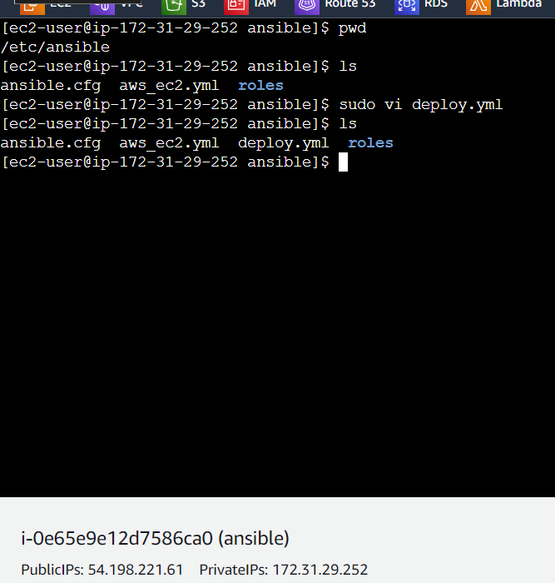

--- apply the playbook
- ansible-playbook deploy.yml
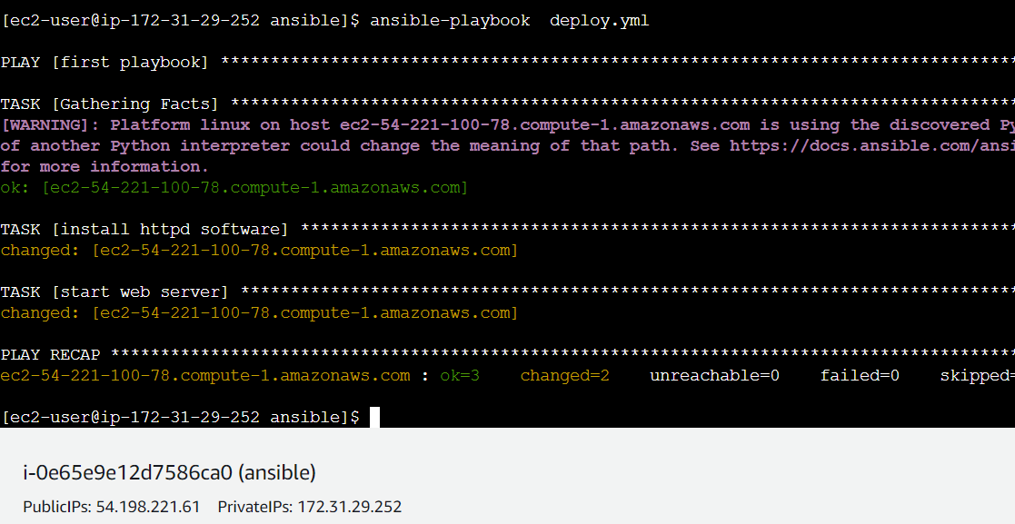

- check in node
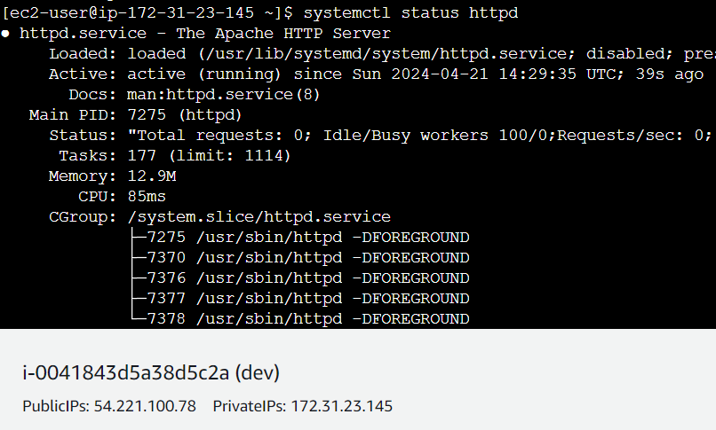
--- option 1 :::::::create a one node with same tags {dev} and connect to the node copy paste the public key
---option2 :;:::::: create a AMI from the existing dev node. Launch the instance from ami with same tags {{dev}}. In this procress noo need to copy paste the keys.
------ after completing of above any one step . goo ansible master give list and graph commad u will get new node details
---------------------------------------------------------------------------
THIS IS FOR HOST = GROUP NAME
---This group process I am doing in same ansible
--If u have interest create a new resources doo same process until
Aws_ec2.yml creation from here everything in changed
- Edit the aws_ec2.ymal
- Iam commented filters and added key_groups

---
plugin: amazon.aws.aws_ec2
regions:
- us-east-1
#filters:
# tag:Name:
# - dev
#add multiple tag names here if required

keyed_groups:
# add hosts to tag_Name_value groups for each aws_ec2 host's tags.Name variable.
- key: tags.Name
prefix: tag_Name_
separator: ""
groups:
# add hosts to the group dev if any of the dictionary's keys or values is the word 'dev'.
development: "dev” in (tags|list)"
filters:
tag:Name:
- 'dev'
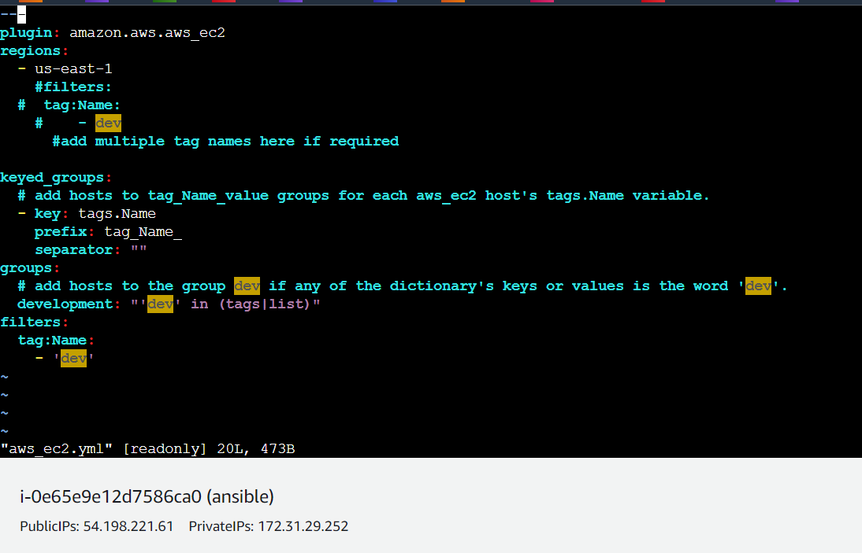

--- give graph command to get details. In ungrouped one instance addeed
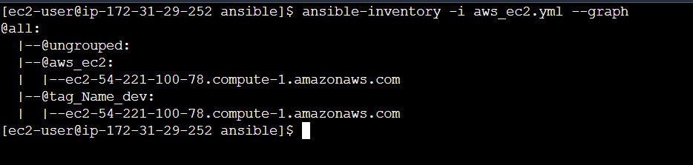

--- give list command to get details group in added instances
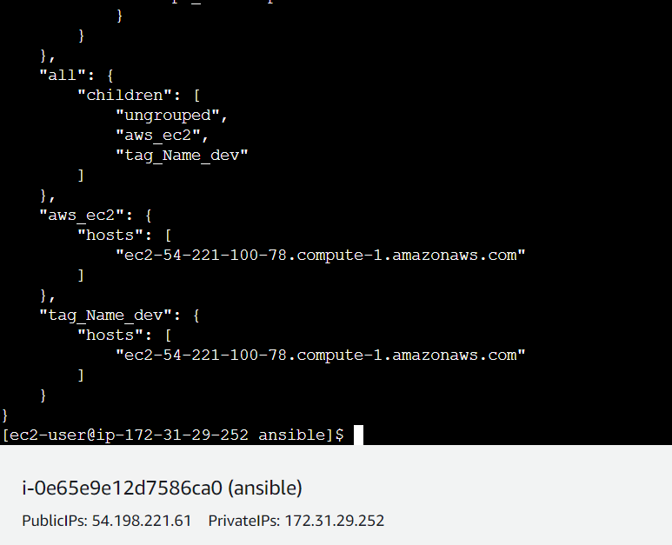

---create a deploy.yml

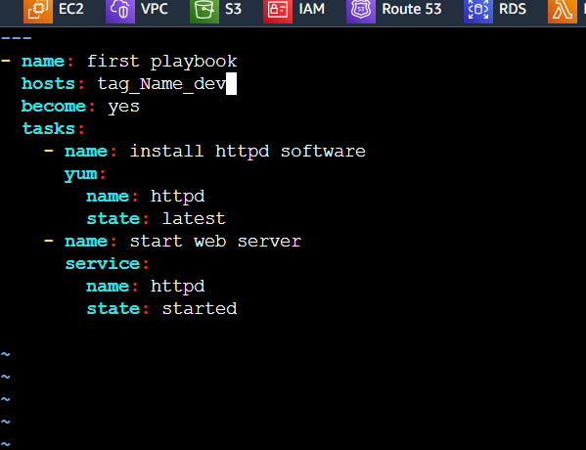
- Deploy the deploy.yaml file
---ansible-playbook deploy.yaml
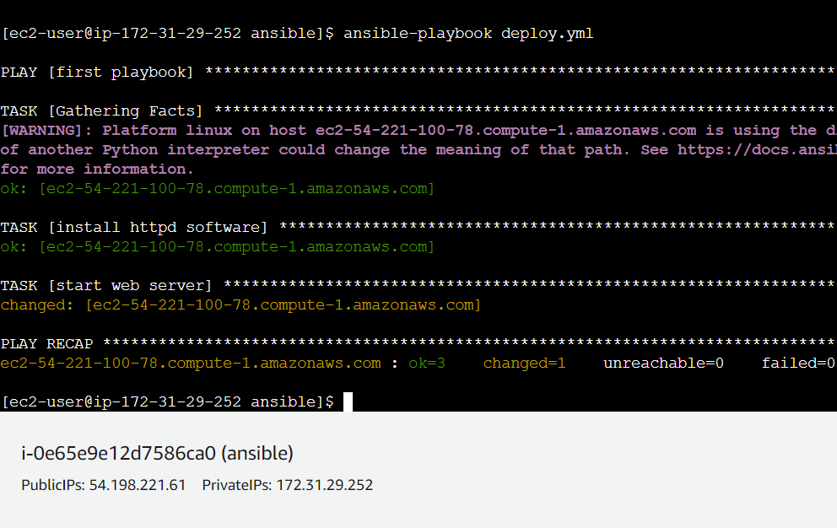

---- Here instance tag name dev and group name dev so dev instance is added into dev group
--- you will create a new group in aws_ec2.yml with same instance name dev give list command to verify the instance groups

